Soft Real-Time System

Definition
# Source: AI Source: Provided by: [Data Path: Persons Table -> ID Column: 1, Name_En Column: Motasem Essam] -> From: [ChatGPT] on [1/21/2026]
A Soft Real-Time System is a type of real-time system where meeting deadlines is important but not absolutely critical. Unlike hard real-time systems, occasional delays are tolerable, and the system can still function, though performance may degrade.

Key Characteristics
# Source: AI Source: Provided by: [Data Path: Persons Table -> ID Column: 1, Name_En Column: Motasem Essam] -> From: [ChatGPT] on [1/21/2026]
- Flexible Deadlines – Missing a deadline is undesirable but doesn’t cause catastrophic failure.
- Graceful Degradation – The system can continue operating even if some deadlines are missed.
- Performance Focused – Timely responses improve system quality, but occasional delays are acceptable.
- Less Critical Safety – Typically used in applications where delays may annoy or reduce efficiency but won’t harm life or property.

Examples
# Source: AI Source: Provided by: [Data Path: Persons Table -> ID Column: 1, Name_En Column: Motasem Essam] -> From: [ChatGPT] on [1/21/2026]
- Video streaming apps – Small delays may cause buffering but don’t crash the system.
- Online gaming – Lag affects gameplay but is not fatal.
- E-commerce websites – Slow responses may frustrate users but won’t cause disaster.
- Multimedia systems – Audio/video synchronization might slightly degrade.

Difference from Hard Real-Time Systems
# Source: AI Source: Provided by: [Data Path: Persons Table -> ID Column: 1, Name_En Column: Motasem Essam] -> From: [ChatGPT] on [1/21/2026]
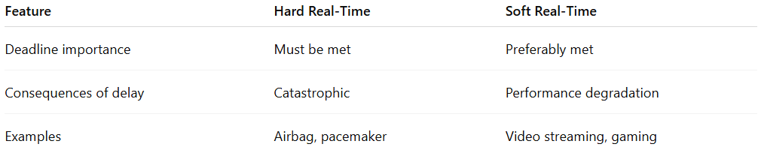
Feature | Hard Real-Time | Soft Real-Time
Deadline importance | Must be met | Preferably met
Consequences of delay | Catastrophic | Performance degradation
Examples | Airbag, pacemaker | Video streaming, gaming

In short, soft real-time systems aim for timely responses, but occasional delays are acceptable and non-fatal.

